# с if и goto:

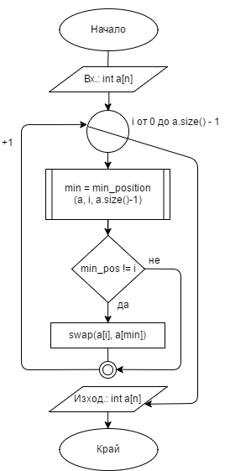

#include <iostream>

#include <windows.h>

using namespace std;

int main()

{

const int N = 5;

int arr[N] = { 31,34,12,22,11 };

int i = 0, j = 1;

label:

if (i < N)

{

int min = arr[i];

int index = i;

j = i + 1;

label2:

if (j < N)

{

if (arr[j] < min)

{

min = arr[j];

index = j;

}

j++;

goto label2;

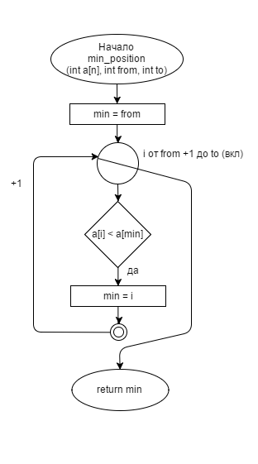

}

else

{

int temp = arr[i];

arr[i] = min;

arr[index] = temp;

i++;

goto label;

}

}

for (int i = 0; i < N; i++) {

cout << arr[i] << endl;

}

return 0;

}

традиционно:

void selection_sort(vector<int> &a) {

int i; /* the next position to be set to the minimum */

for (i = 0; i < a.size() - 1; i++) {

/* find the position of the minimum */

int min = min_position(a, i, a.size() - 1);

if (min != i) {

swap(a[min], a[i]);

}

}

}